# CS 255 System Design Document Template

This template lays out all the different sections that you need to complete for Project Two. Each section has guidance to prompt your thinking. You will need to continually reference the interview transcript as you work to make sure that you are addressing your client’s needs. There is no required length for the final document. Instead the goal is to complete each section based on what your client’s needs are. Remove this note when you are finished, and replace all bracketed text with the relevant information.

## UML Diagrams

### UML Use Case Diagram

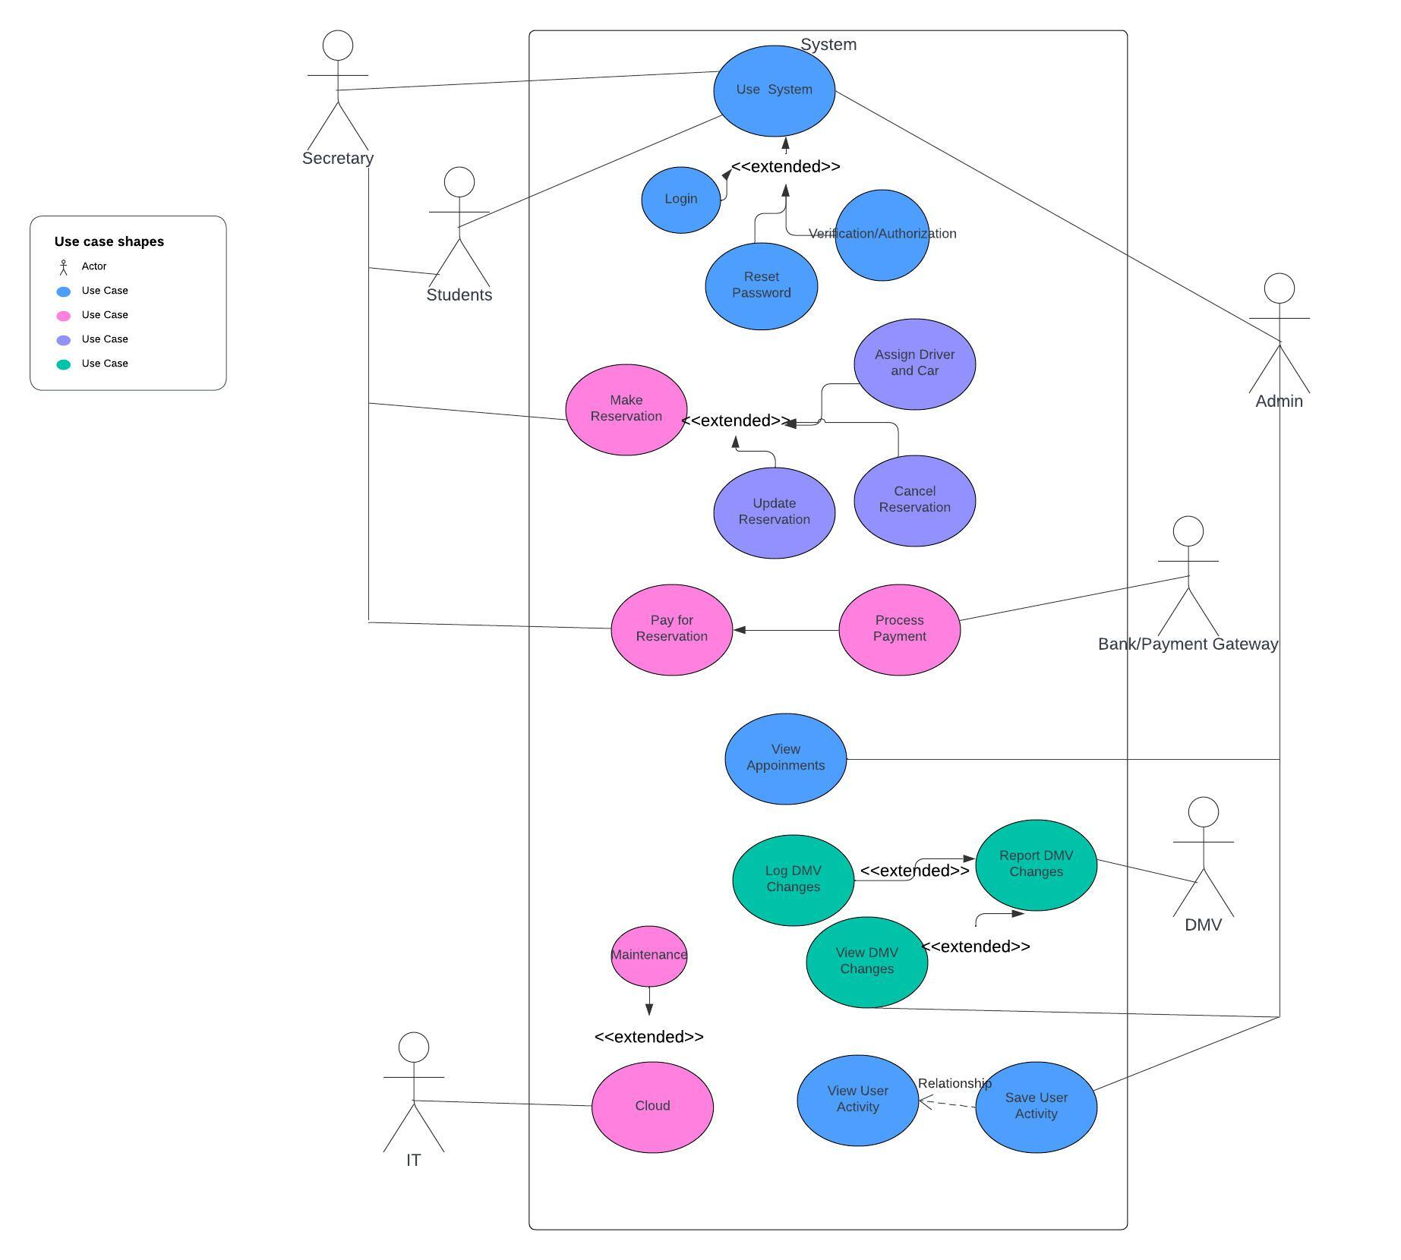

### UML Activity Diagrams

*Student User Activity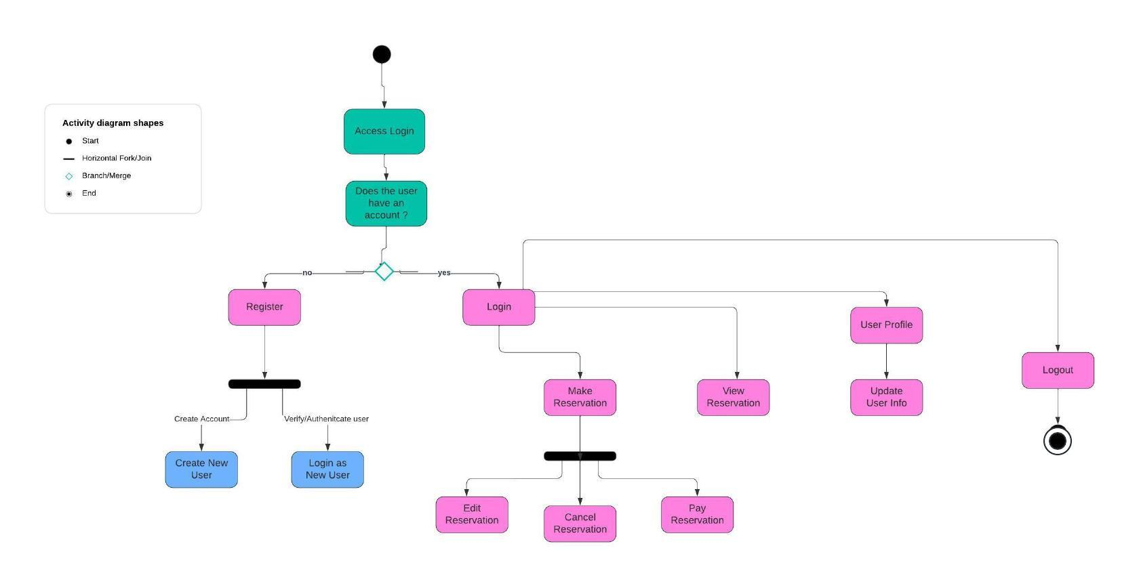   
  
External Bank User Activity*

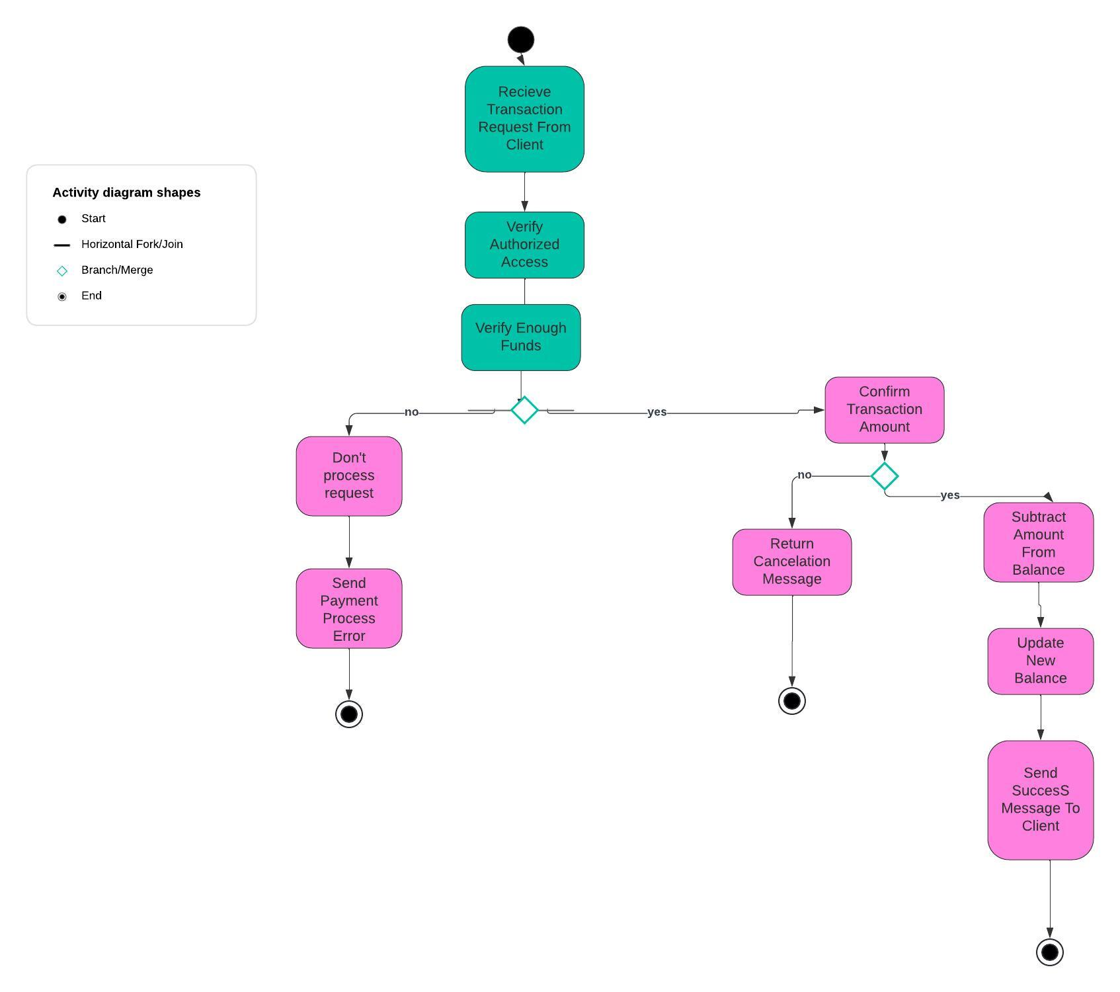

*Sequence Diagram for bank*

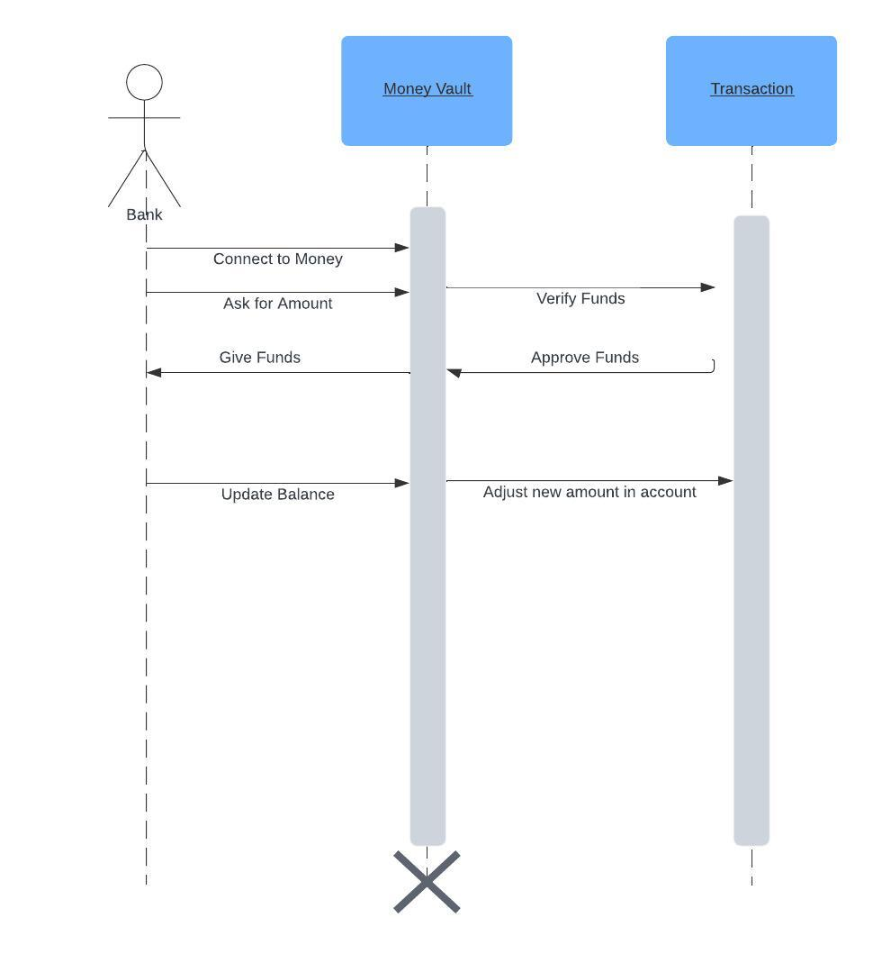

### UML Sequence Diagram

### UML Class Diagram

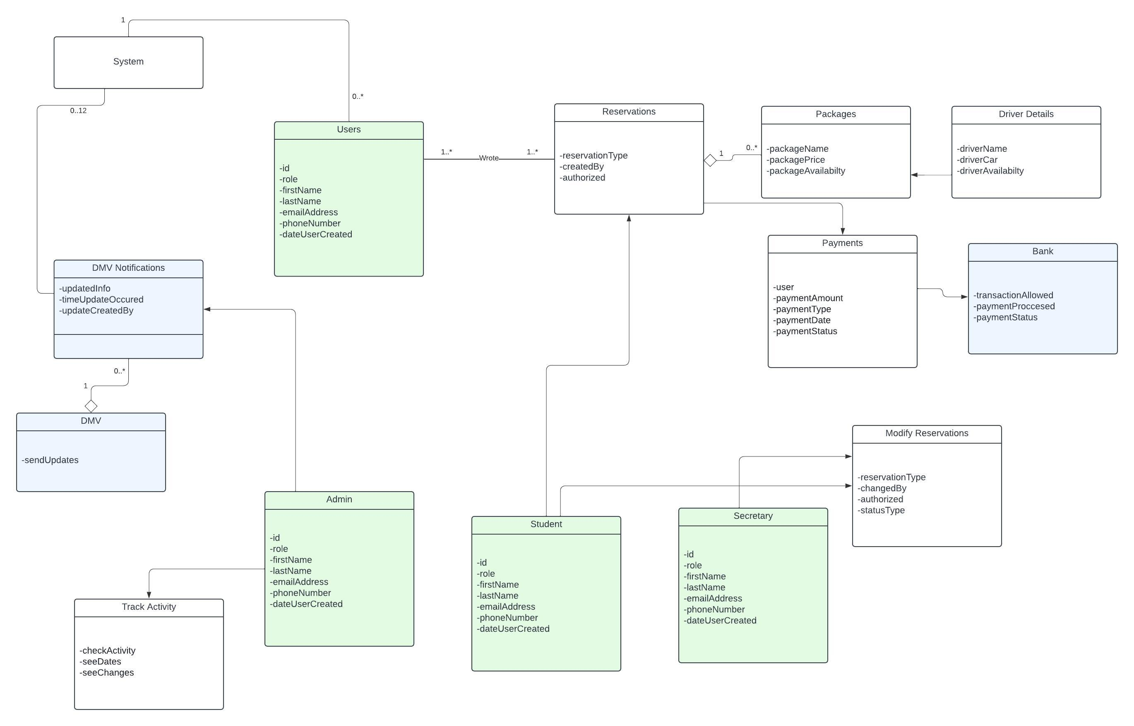

## Technical Requirements

*The technical requirements involved would be a client user interface that allows different people to make reservations to take driving classes. The interface can be developed quickly in python using the web framework and since it will live in the cloud like Cloudflare, any PC, Mac, or Linux user should be able to access the system. This UI needs to be responsive to support mobile devices. As far as the server, this could be handled with Java since this could be an enterprise like system and java is a strict language so it will manage making sure the correct data types are being handled. The data that is involved would need to be stored in a relational database such as mySQL. This database should support daily backups to prevent data loss. The system can also be containerized therefore in a part of the system breaks, it does not affect other parts of the system that could still be in use. There can be a daily API call that interacts with the DMV to check for any new notifications in regards to policy changes. These updates can be saved in the database and then the client can look for the changes. IT department should use cloud tools to monitor the performance and health of the resources being used to support the system. There should be an activity log to track users that access the system. This includes checking for unusual repetitive I.P. addresses and accounts that are showing that are being locked out. Resources should be check to make sure there isn’t high CPU or storage usage that could affect the performance and the speed of the system. The system also needs to handle security effectively so making sure 2FA is involved when it comes to creating a user and signing into a user. The need for security checks in regards to payments is vital as as well. There needs to be a authentication setup in regards to the user roles to make sure that users are not seeing data they should not be. When creating users and handling passwords, encryption needs to be used before saving into the database. The cloud platform should also support migration in a way that is seamless in case resources change and scale for the future. The system should also include accessibility features to not limit who can operate the system. It is also advised to have this implanted to avoid legal action.*